# Assignment Description

This program will determine if a user has enough RAM to do certain tasks.

Prompt the user for the amount of RAM their computer has in GB. Then you will display the list of tasks below that the user might do with the computer. Based on the task chosen, inform the user if the amount of RAM they have is sufficient.

# GitHub URL (optional)

[https://github.com/wesleyhixon/Programming-Assignments/tree/f4499cc021a41f4f8468059617111cd09455480c/M03%20Programming%20Assignment%201](https://github.com/wesleyhixon/Programming-Assignments/tree/f4499cc021a41f4f8468059617111cd09455480c/M03 Programming Assignment 1)

# Readme Documentation

Input Information: User inputs an amount of RAM and selects a task from the list

Output Information: Program outputs a list of tasks which require RAM and tells the user whether their amount of RAM is sufficient for the selected task.

# Flowchart Screen Shots (optional)

Screen shot(s) here

# UML and Use Case Diagrams (optional)

Screen shot(s) here

# Source Code of All files (.h, .cpp)

#include <iostream>

using namespace std;

/*

Program Name: Computer Specifications

Author: Wesley Hixon

Date Last Updated: 06/18/2024

Purpose: This program will determine if a user has enough RAM to do certain tasks.

Prompt the user for the amount of RAM their computer has in GB. Then you will display the list of tasks below that the user might do with the computer.

Based on the task chosen, inform the user if the amount of RAM they have is sufficient.

*/

int main(){

// Initializing variables

int userSelection, userRAM;

int androidStudioRAM = 12, vsCodeRAM = 8, gamingRAM = 16, chromeRAM = 8, multipleProgrammingRAM = 20, zoomRAM = 8,

emailRAM = 6, documentRAM = 6, everythingRAM = 32;

// Prompting user for amount of RAM

cout << "Enter the amount of RAM in GB: ";

cin >> userRAM;

// Validating input

if(userRAM < 0){

cout << "Please enter a valid amount of RAM. Exiting...";

return 0;

}

// This statement only triggers if cin fails

if(!cin){

cout << "Please enter an integer. Exiting... ";

return 0;

}

// Prompting the user for menu selection

cout << "Choose the task you want to do on your computer from the following list: \n"

"1. Android Studio \n"

"2. Visual Studio Code \n"

"3. Gaming \n"

"4. Web Browsing with Chrome \n"

"5. Multiple Programming Tasks (both Android Studio and Visual Studio Code) \n"

"6. Zoom \n"

"7. Email \n"

"8. Create and edit documents \n"

"9. Everything listed above \n";

cin >> userSelection;

// Validating input

if(userSelection < 1 or userSelection > 9){

cout << "Please select a valid option. Exiting...";

return 0;

}

if(!cin){

cout << "Please select a valid option. Exiting...";

return 0;

}

// This switch statement handles every menu option

// Each RAM use case is compared to the amount of RAM the user inputs

// The user is then told whether they have enough RAM

switch(userSelection){

case 1:

if(userRAM >= androidStudioRAM){

cout << "Congratulations! You have sufficient RAM for your task.";

}

else{

cout << "Sorry the RAM you have is not sufficient.";

}

break;

case 2:

if(userRAM >= vsCodeRAM){

cout << "Congratulations! You have sufficient RAM for your task.";

}

else{

cout << "Sorry the RAM you have is not sufficient.";

}

break;

case 3:

if(userRAM >= gamingRAM){

cout << "Congratulations! You have sufficient RAM for your task.";

}

else{

cout << "Sorry the RAM you have is not sufficient.";

}

break;

case 4:

if(userRAM >= chromeRAM){

cout << "Congratulations! You have sufficient RAM for your task.";

}

else{

cout << "Sorry the RAM you have is not sufficient.";

}

break;

case 5:

if(userRAM >= multipleProgrammingRAM){

cout << "Congratulations! You have sufficient RAM for your task.";

}

else{

cout << "Sorry the RAM you have is not sufficient.";

}

break;

case 6:

if(userRAM >= zoomRAM){

cout << "Congratulations! You have sufficient RAM for your task.";

}

else{

cout << "Sorry the RAM you have is not sufficient.";

}

break;

case 7:

if(userRAM >= emailRAM){

cout << "Congratulations! You have sufficient RAM for your task.";

}

else{

cout << "Sorry the RAM you have is not sufficient.";

}

break;

case 8:

if(userRAM >= documentRAM){

cout << "Congratulations! You have sufficient RAM for your task.";

}

else{

cout << "Sorry the RAM you have is not sufficient.";

}

break;

case 9:

if(userRAM >= everythingRAM){

cout << "Congratulations! You have sufficient RAM for your task.";

}

else{

cout << "Sorry the RAM you have is not sufficient.";

}

break;

}

return 0;

}

# Three Use Case Screen Shots

The can all be in a single screen shot

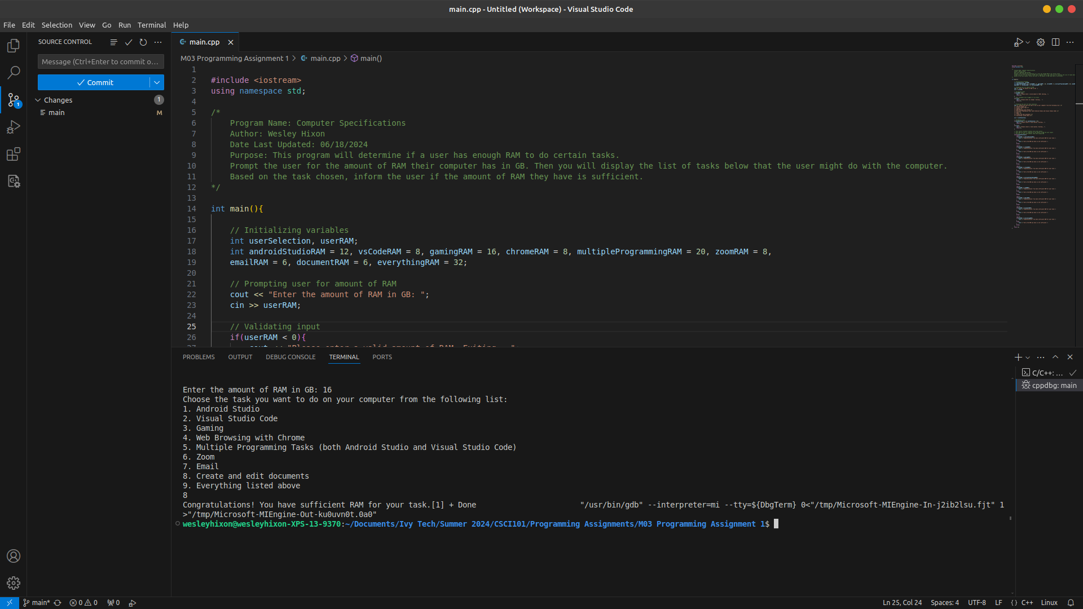

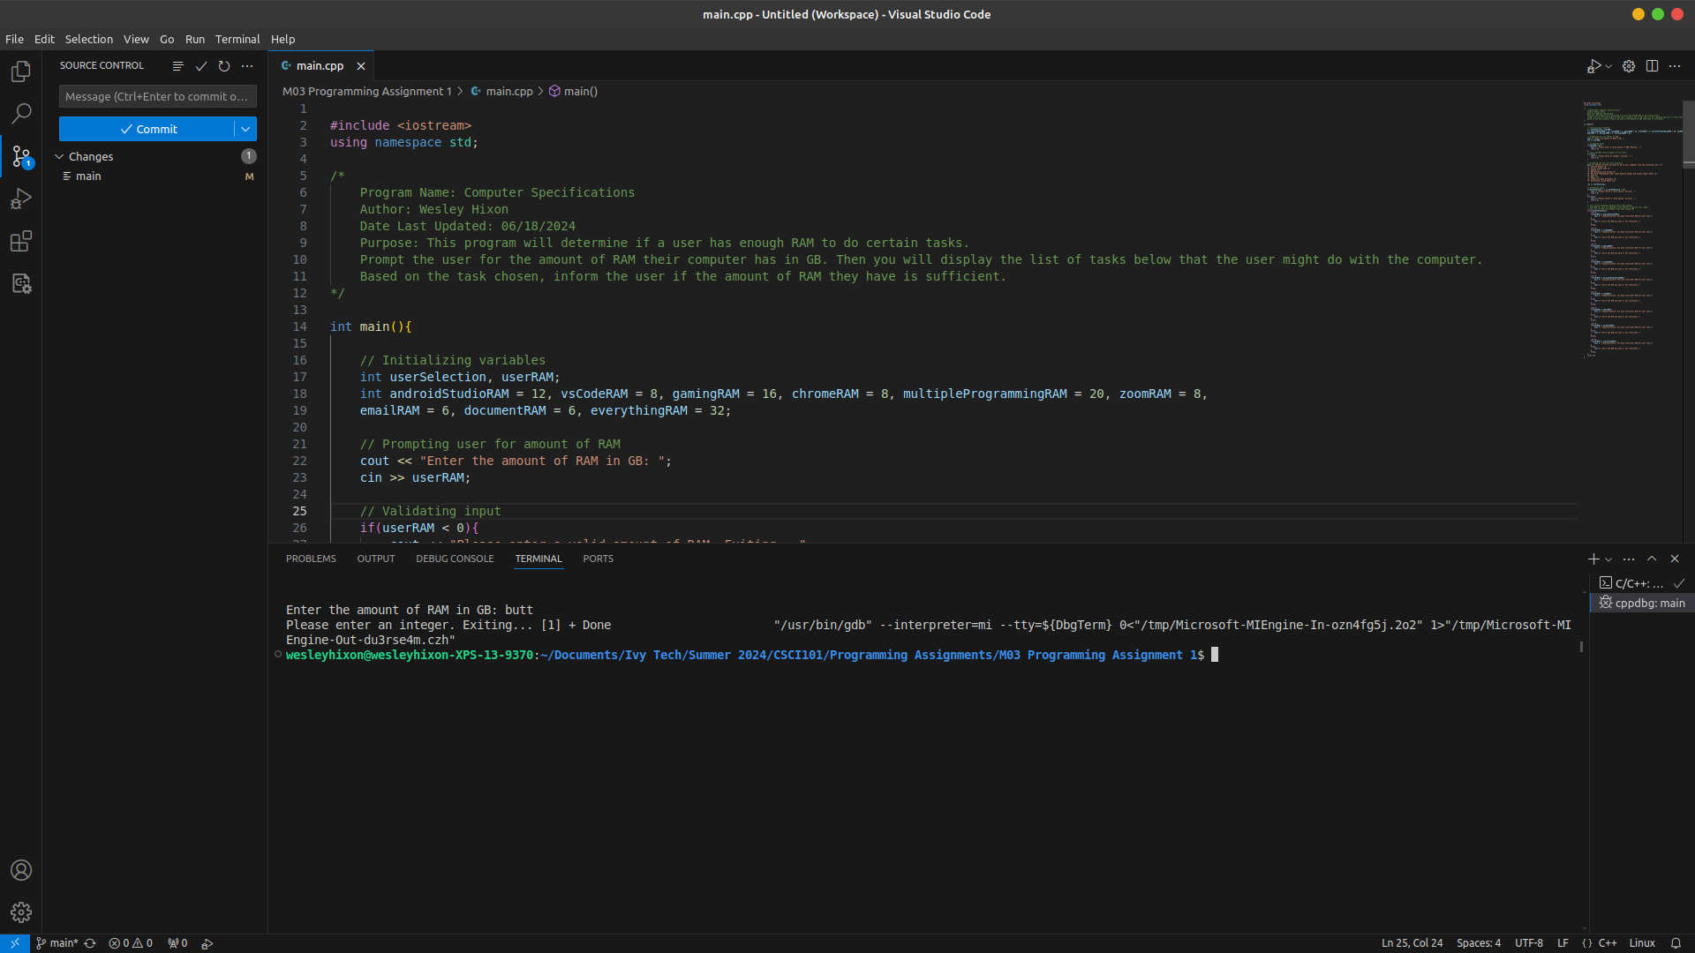

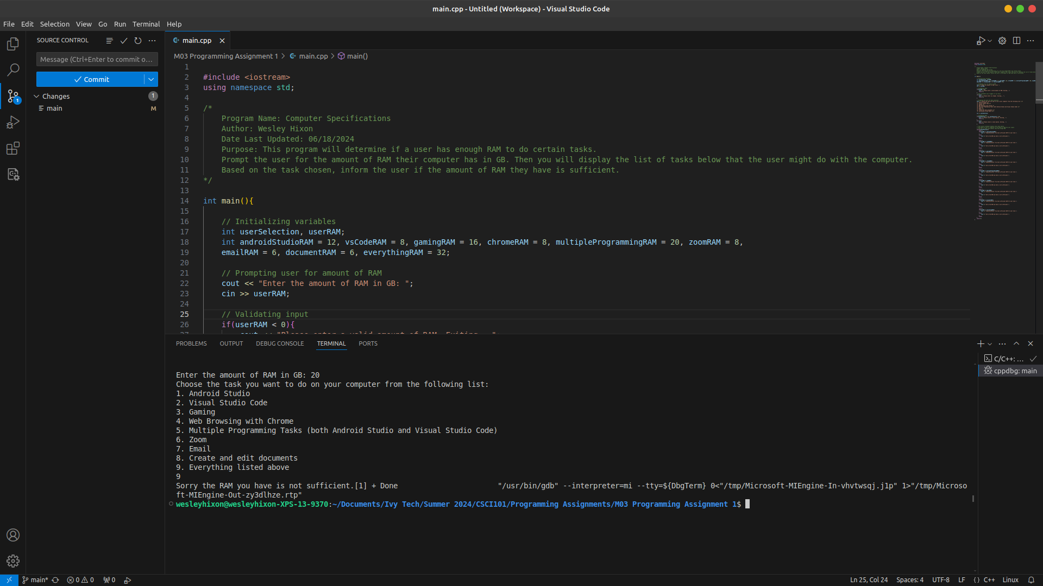Please make sure all screen shots and text are clearly viewable for faster / easier grading!